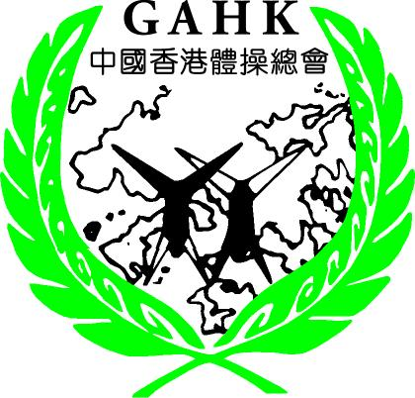
Organized by: Subvented By:
The Gymnastics Association of Hong Kong, China Leisure and Cultural Services Department

The Gymnastics Association of Hong Kong, China
Hong Kong Artistic Gymnastics International Invitational Championships 2016-17
(Chiu Wai Chung Cup)

Organizer: | The Gymnastics Association of Hong Kong, China  Room 1002, Olympic House, 1 Stadium Path,  So Kon Po, Causeway Bay, Hong Kong  Tel: (852) 2504 8233 Fax: (852) 2882 8590  Contact person: Mr. Albert NG  Website : www.gahk.org.hk  E-mail: mail@gahk.org.hk
Date: | 12 – 17 January, 2017
Venue: | Ma On Shan Sports Centre(MOSSC)  14 On Chun Street, Ma On Shan, Shatin
Apparatus: | Janssen-Fritsen
Schedule (Provisional): | Date | Particulars
Schedule (Provisional): | 12 January 2017  (Thursday) | Arrival of Delegations
Schedule (Provisional): | 13 January 2017  (Friday) | Training  Orientation meeting  Judges’ meeting
Schedule (Provisional): | 14 January 2017  (Saturday) | Official Training  Qualification MAG & WAG
Schedule (Provisional): | 15 January 2017  (Sunday) | Official Training  Apparatus Finals MAG & WAG  Farewell Party
Schedule (Provisional): | 16 January 2017  (Monday) | Sight-seeing
Schedule (Provisional): | 17 January 2017  (Tuesday) | Departure

Competition Format: | Qualifications & Individual All-Around (CI & II)  - The competition will consist of the Senior and Junior Men’s and Women’s Qualifications(CI), Individual All-Around (CII), and Apparatus Finals (CIII).  - The competitions will take place according to FIG Code of Points 2013~2016.  - The total scores of gymnasts who perform on all the apparatus in CI (6 apparatus for Men and 4 apparatus for Women) will determine the top 3 winners of Individual All-Around (3 Senior and 3 Junior), which are limited to 2 gymnasts per country.
Competition Format: | Apparatus Finals (C III)  - For each apparatus, the top 8 gymnasts in CI (8 Senior and 8 Junior) will be qualified to CIII, which are limited to 2 gymnasts per country.  - To qualify for the vault final two vaults are necessary in CI.  - 1 wild card will be used if no host country gymnast is qualified to the Finals in each apparatus.
Awards: | - Medals will be awarded to the top 3 winners of Individual All-around and Apparatus Finals (maximum 2 gymnasts per country)  - All participants will be presented a Certificate of Participation
Delegation: | Capacity |  |  | MAG | WAG | Total
Delegation: | Head of Delegation |  |  | 1 |  | 1
Delegation: | Team Manager |  |  | 1 | 1 | 2
Delegation: | Coach |  |  | 2 | 2 | 4
Delegation: | Judge |  |  | 3 | 3 | 6
Delegation: | Doctor / Physiotherapist |  |  | 1 | 1 | 2
Delegation: | Gymnasts (Senior) |  |  | 6 | 6 | 12
Delegation: | Gymnasts (Junior) |  |  | 6 | 6 | 12
Delegation: |  |  |  |  | Total: | 39
Age: | MAG | Senior | 18 or above (born on or before 1998)
Age: | MAG | Junior | 14~17 years (born between 1999 to 2002)
Age: | WAG | Senior | 16 or above (born on or before 2000)
Age: | WAG | Junior | 13~15 years (born between 2001 to 2003)
Judges: | Each Federation may send 3 MAG and 3 WAG judges. All judges should be a FIG 13th Cycle International Judges Brevet or judge’s holder.  All judges have to apply working visa for providing service in HK in compliance with HKG Immigration Department. Please refer to visa request for your necessary actions.

Accommodation and Meals: | There are 2 accommodation options:  A. Regal Riverside Hotel  Address: 34-36 Tai Chung Kiu Road, Shatin, Hong Kong  Tel: (852) 2649 7878  Website: http://www.regalhotel.com/Regal-Riverside-Hotel/Main/Hotel-Home.aspx  - USD400 for standard double/triple room per person (breakfast included)  - USD450 for single room per person (breakfast included)  - USD600 per person will be charged for additional persons.  - Expenses included in this fee :  - Accommodation (breakfast only)  - Transportation from the airport to the hotel and back  - Transportation from the hotel to the competition hall and back  - Breakfast and Farewell Party on Sunday, 15 January 2017  - One-day local tour on 16 January 2017  - Check-In Time: 2 pm, Check-Out Time: 12 noon  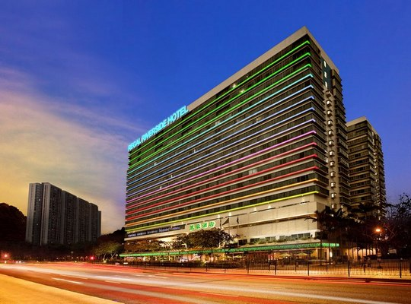  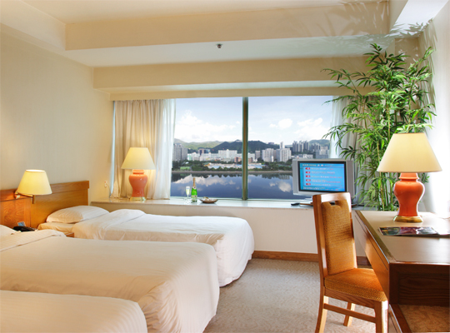  B. Wu Kai Sha Youth Village  Address: 2 On Chun Street, Ma On Shan, Shatin, N.T.  Tel: (852) 2642 9420  Website: http://www.ymca.org.hk/eng/index.php?c=88&t=1  - USD2,500 for 4 – 8 person dormitory  - Expenses included in this fee :  - Accommodation (breakfast only)  - Transportation from the airport to the youth village and back  - Breakfast and Farewell Party on Sunday, 15 January 2017  - One-day local tour on 16 January 2017  - Check-In Time: 4 pm, Check-Out Time: 1:30 pm  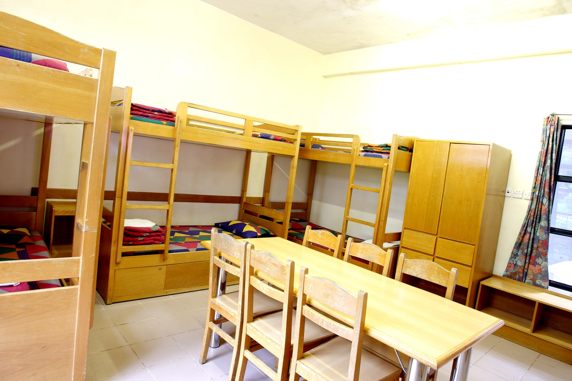
Payment Methods: |  | Deposit: 50% of the total amount has to be credited to The Gymnastics Association of Hong Kong, China on or before 12 November 2016.  Payment must be made by telegraphic transfer (in US dollars) to the bank account shown below:  - Name of Bank : The Hong Kong and Shanghai Banking Corporation Limited (HSBC)  - Branch: Causeway Bay  - Address: 1/F, Causeway Bay Plaza 2, 463-483 Lockhart Road, Causeway Bay, Hong Kong  - Account Number: 047-670799-838  - Beneficiary: The Gymnastics Association of Hong Kong, China  All expenses of the delegations are to be borne by the participating federations
Local Transportation: |  | Delegations will be picked-up at the Hong Kong International Airport, or at the Hung Hom Railway Station (free) only, also free transportation between hotel and the gymnasium will be provided by the Organizing Committee.  Just 10 mins walk away from Wu Kai Sha Youth Village to gymnasium. No transportation will be provided  *Please pay attention that we may not provide any transportation if you have late submission.
Time Frame and Deadlines: |  | Provisional Registration | 12 October 2016
 |  | Definitive Registration | 1 November 2016
 |  | Documents for Visa Application | 1 November 2016
 |  | Accommodation Form | 12 November 2016
 |  | Deposit (50% of total amount) | 12 November 2016
 |  | Final Payment | 12 December 2016
 |  | Travel Details Submission | 12 December 2016
Insurance: |  | The host federation and the organizing committee will not be held responsible for any liabilities in case of accidents, illness, repatriation and the like. Each member of the federations needs to have a valid health and accident insurance.
Visa: |  | The GAHK will issue invitation letter for all participants of delegation. Please complete the form and send to us on or before 1 November 2016.  Due to the HKSAR Government requirement, all visitors come to HK for providing service regardless paid or no paid, all have to apply working visa. All judges have to fill in HKG Immigration Department forms (ID 990A) http://www.immd.gov.hk/pdforms/ID990A.pdf with certificates and passport copy to us for submission. It needs 4 – 6 weeks for application. Please complete the form and send to us on or before 1 November 2016. Late submission will not be guaranteed to apply successfully.
Enquiries: |  | Mr. Albert NG  Telephone: (852) 2504 8233 / Fax: (852) 2882 8590  E-mail: mail@gahk.org.hk or albertng@gahk.org.hk
Date: 12 August 2016

Organized by: Subvented By:
The Gymnastics Association of Hong Kong, China Leisure and Cultural Services Department
The Gymnastics Association of Hong Kong, China
Room 1002, Olympic House, 1 Stadium Path, So Kon Po, Causeway Bay, Hong Kong
TEL : (852) 2504 8233 FAX : (852) 2882 8590 E-MAIL: mail@gahk.org.hk

Hong Kong Artistic Gymnastics International Invitational Championships 2016-17
12 – 17 January, 2017

Federation : E-mail:

Contact person : Phone :

Provisional Registration Form
(Please submit on or before 12 October 2016)
Number of participants
Head of Delegation
Team Manager
MAG Coach
WAG Coach
Judge MAG
Judge WAG
Doctor / Physiotherapist
MAG Gymnast (Senior)
MAG Gymnast (Junior)
WAG Gymnast (Senior)
WAG Gymnast (Junior)
Others
Total :

Name of MAG Judge :

Name of WAG Judge :

Date : Signature & Stamp :
Organized by: Subvented By:
The Gymnastics Association of Hong Kong, China Leisure and Cultural Services Department
The Gymnastics Association of Hong Kong, China
Room 1002, Olympic House, 1 Stadium Path, So Kon Po, Causeway Bay, Hong Kong
TEL : (852) 2504 8233 FAX : (852) 2882 8590 E-MAIL: mail@gahk.org.hk
Hong Kong Artistic Gymnastics International Invitational Championships 2016-17
12 – 17 January, 2017
Federation : E-mail:
Contact person : Phone :
Definitive Registration Form
(Please submit on or before 1 November 2016, with “Word document”)
 | Function | Surname | Given Name | Gender | DOB(DD/MM/YYYY)
1 | Head of Delegation |  |  |  | / /
2 | Team Manager |  |  |  | / /
3 | Coach (MAG / WAG) |  |  |  | / /
4 | Coach (MAG / WAG) |  |  |  | / /
5 | Judge MAG 1 |  |  |  | / /
6 | Judge MAG 2 |  |  |  | / /
7 | Judge MAG 3 |  |  |  | / /
8 | Judge WAG 1 |  |  |  | / /
9 | Judge WAG 2 |  |  |  | / /
10 | Judge WAG 3 |  |  |  | / /
11 | Doctor /Physiotherapist |  |  |  | / /
12 | Gymnast (Senior) |  |  |  | / /
13 | Gymnast (Senior) |  |  |  | / /
14 | Gymnast (Senior) |  |  |  | / /
15 | Gymnast (Senior) |  |  |  | / /
16 | Gymnast (Senior) |  |  |  | / /
17 | Gymnast (Senior) |  |  |  | / /
18 | Gymnast (Junior) |  |  |  | / /
19 | Gymnast (Junior) |  |  |  | / /
20 | Gymnast (Junior) |  |  |  | / /
21 | Gymnast (Junior) |  |  |  | / /
22 | Gymnast (Junior) |  |  |  | / /
23 | Gymnast (Junior) |  |  |  | / /
24 | Others (Please specify) |  |  |  | / /
(Please supplement with separate sheet/s if necessary)
Date : Signature & Stamp :
Organized by: Subvented By:
The Gymnastics Association of Hong Kong, China Leisure and Cultural Services Department
The Gymnastics Association of Hong Kong, China
Room 1002, Olympic House, 1 Stadium Path, So Kon Po, Causeway Bay, Hong Kong
TEL : (852) 2504 8233 FAX : (852) 2882 8590 E-MAIL: mail@gahk.org.hk

Hong Kong Artistic Gymnastics International Invitational Championships 2016-17
12 – 17 January, 2017
Federation : E-mail:

Contact person : Phone :
Visa Requests Form
(Please submit on or before 1 November 2016, with “Word document”)
 | Surname | Given Name | Gender | DOB (DD/MM/YYYY) | Nationality | Passport Number | Function
1.
2.
3.
4.
5.
6.
7.
8.
9.
10.
11.
12.
13.
14.
15.
16.
(Please supplement with separate sheet/s if necessary)

Date : Signature & Stamp :
Organized by: Subvented By:
The Gymnastics Association of Hong Kong, China Leisure and Cultural Services Department
The Gymnastics Association of Hong Kong, China
Room 1002, Olympic House, 1 Stadium Path, So Kon Po, Causeway Bay, Hong Kong
TEL : (852) 2504 8233 FAX : (852) 2882 8590 E-MAIL: mail@gahk.org.hk

Hong Kong Artistic Gymnastics International Invitational Championships 2016-17
12 – 17 January, 2017
Federation : E-mail:

Contact person : Phone :

Accommodation Form (Regal Riverside Hotel)
(Please submit on or before 12 November 2016, with “Word document”)
room type  (single/double/triple),  for 1/2/3/4/5/6 to be shared with (IF APPLICABLE) | Full Name  ( Surname, given name) | Passport no. | Capacity | Price per person (usd) | Total price (usd)
 |  |  |  | Total
(Please supplement with separate sheet/s if necessary)
Date : Signature & Stamp :
Organized by: Subvented By:
The Gymnastics Association of Hong Kong, China Leisure and Cultural Services Department
The Gymnastics Association of Hong Kong, China
Room 1002, Olympic House, 1 Stadium Path, So Kon Po, Causeway Bay, Hong Kong
TEL : (852) 2504 8233 FAX : (852) 2882 8590 E-MAIL: mail@gahk.org.hk

Hong Kong Artistic Gymnastics International Invitational Championships 2016-17
12 – 17 January, 2017
Federation : E-mail:

Contact person : Phone :

Accommodation Form (Wu Kai Sha Youth Village)
(Please submit on or before 12 November 2016, with “Word document”)
 | Surname | Given Name | Gender | Capacity | Total price (usd)
1.
  Please tick the appropriate box
  4-person Dormitory
  6-person Dormitory
  8-person Dormitory
2.
3.
4.
5.
6.
7.
8.
9.
10.
11.
12.
13.
14.
15.
16.
(Please supplement with separate sheet/s if necessary)

Date : Signature & Stamp :
Organized by: Subvented By:
The Gymnastics Association of Hong Kong, China Leisure and Cultural Services Department
The Gymnastics Association of Hong Kong, China
Room 1002, Olympic House, 1 Stadium Path, So Kon Po, Causeway Bay, Hong Kong
TEL : (852) 2504 8233 FAX : (852) 2882 8590 E-MAIL: mail@gahk.org.hk

Hong Kong Artistic Gymnastics International Invitational Championships 2016-17
12 – 17 January, 2017
Federation : E-mail:

Contact person : Phone :

Travel Details
(Please submit on or before 12 December 2016)

Arrival
Date | Arrival time | Fight / Train no. | Origin | No. of person | No. of Luggage

Departure
Date | Departure time | Fight / Train no. | Destination | No. of person | No. of Luggage

Date : Signature & Stamp :

*Please pay attention that we may not provide any transportation if you have late submission.

